Environment and how to protect it – text and exercises created by Eva Poláková for the Comenius Partnership project “Challenging the Greenhouse Effect” (2009-2011)

Lesson 1 - Introduction

Warm-up

What is the environment? Discuss this question with your neighbour and write your definition. Then compare it with Text 1 – Definitions

Text 1 - Definitions
1. The environment = the air, water and land on Earth, which can be harmed by human activities
(eg. Some chemicals used in intensive farming are very dangerous for the environment.)
2. The environment = the people and things that are around you in your life, for example the buildings you use, the people you live or work with and the general situation you are in
(eg. The company tried to provide a safe environment for the workers.)
3. The environment = the natural features of a place, for example its weather, the type of land it has, and the type of plants that grow in it - habitat.
(eg. This very adaptable creature will eat different foods in different environments.)
In this module, we will use the term ENVIRONMENT from definition 1.
Environmental = concerning or affecting the air, land or water on Earth (eg. the environmental damages caused by the chemical industry / an international meeting to discuss environmental issues / the environmental impact of pollution form cars)
Environmentally friendly = not harming the environment (eg. environmentally friendly packaging)
Word focus: ¨
- good for the environment: environmentally friendly, eco-friendly, sustainable, recyclable, biodegredable, renewable, organic
- people who want to protect the environment: greens, eco-warriors
- things that cause harm to the environment: pollution, greenhouse effect, global warming, acid rain, deforestation, fossil fuels, ozone layer depletion
Text 2 – Civilization and the environment
Civilization has brought many advantages to mankind but it also pollutes our environment. Pollution affects air, water, land, forests and other vegetation, animals and people. It is caused by emissions from power stations and factories but also from the exhausts of motor vehicles. Toxic substances mix with vapour in the atmosphere and fall back on earth as acid rain.
Forests are called the lungs of our planet because they enable us to breathe fresh air. They absorb carbon dioxide from the air and give us oxygen in return. And yet we kill them by acid rain and also by cutting trees for commercial profit. The great rain forests in the Amazon basin which cover an area as large as the whole Europe, are being persistently depleted.

Test 1 – Basic problems

Match the most serious environmental problems and their possible solutions:

fossil fuels and global warming renewable resources
waste ozone-friendly products
air pollution caused by vehicles organic farming
products harmful to the environment environmentally friendly transport
intensive farming renewable (sustainable) energy
acid rains recycling

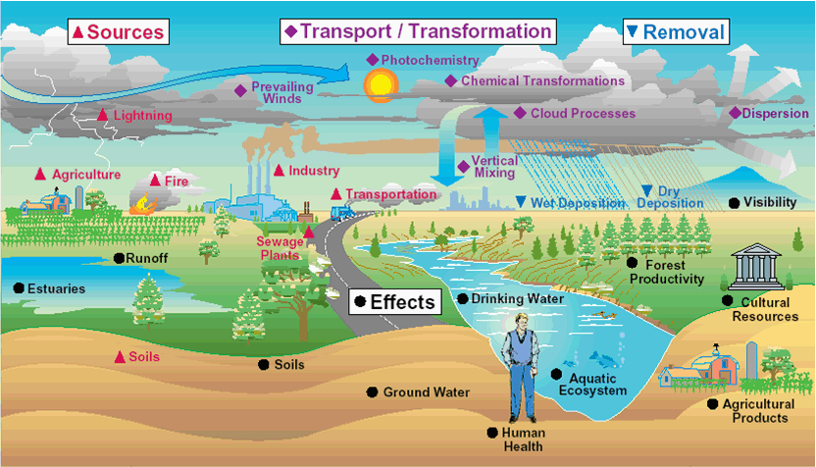

Lesson 2 – Crucial problems

Text 3 – The biggest problems 1
One of the biggest problems these days is the problem of the environment. The steep development of industry in the last 70 years is a great danger for life on the Earth. There are two pressing problems with the atmosphere of our planet which are caused by emitting polluting materials into the earth:
1. The most pressing problem is the depletion of the ozone layer in the stratosphere of the Earth. Ozone absorbs the UV radiation from the sun which is dangerous for all organisms on the Earth. Ozone is decomposed by freons above all. It is necessary to stop using the gas and replace it by another one or avoid using it if possible.
http://en.wikipedia.org/wiki/Ozone_layer
2. The second great problem is the greenhouse effect which is caused by a lot of carbon dioxide and other greenhouse gases (methane, nitrous oxide, sulphur hexafluoride) which are emitted in the air during burning fossil fuels like carbon and oil. This results in global warming. In spite of the fact that the increasing of the temperature is very slow it can cause the thawing of polar icebergs which may have consequences like settlements on the coast endangered by the sea level going up. At the same time it will not be possible for the temperature to rise too high in the future - it would have negative consequences for vegetation on the Earth.
http://en.wikipedia.org/wiki/Greenhouse_effect
http://en.wikipedia.org/wiki/Global_warming

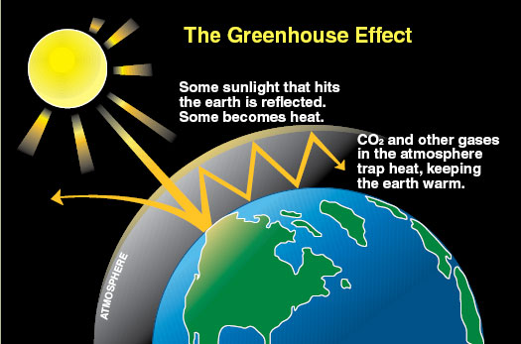

Test 2 – Complete the sentences

1. Burning of f_____________ f______________ (such as coal and oil) leads to increase of the amount of gases like carbon dioxide and methane.

2. G____________ g______________ (like carbon dioxide and methane) result in climate change.

3. Climate change causes g______________ w_______________ (an increase in world temperature).

Text 4 - The biggest problems 2
Another problem, connected with the environment, is the problem of energy. We need energy enough to keep development of industry. There are three types of traditional power stations:
Thermal power stations pollute the air, release smog, flyash, oxides of sulphur, oxides of carbon.
Water power stations destroy the landscape, fish cannot get through and there are not many rivers suitable for water power stations.
Nuclear power stations are very expensive but they do not pollute the air. Many people are afraid that nuclear power stations are not safe and the waste material makes the biggest problem of these power stations.
New sources of energy, called renewable or sustainable, have been used in recent years. The first alternative is solar energy, others include wind power, geothermal power, small-scale hydropower, tidal and wave power, biomass power and anaerobic digestion power.
http://en.wikipedia.org/wiki/Sustainable_energy
For the development of industry we must find not only energy, but also raw materials. The supplies of raw materials will be exhausted and some of them have been replaced with plastics. But there is a big problem with plastics. Scientists must find a technology enabling their utilization not only because they are indestructible and stay in the ground for many years, but also because the supplies of oil (from which plastics are made) are declining as well.
Find the current figures here (Energy): http://www.worldometers.info/

QUIA activity 1 – Rags to riches (environment millionaire)
Would you like to „win“ a million dollars? Try this activity!
http://www.quia.com/rr/568963.html
Lesson 3 – Energy
Text 5 – Energy
A long time ago people used only as much energy as they got from the food they ate. Since then the consumption of energy has only been growing. In today´s technological society, we need energy for every daily activity.
Compared to primitive man we use far more energy, but cannot speak of a shortage of its primary resources. The problem is converting these resources into other forms of energy or mechanical work.
Even in the 21 century the production of the electrical energy has not changed much form the traditional way. It is still based on rotating turbines attached to electrical generators. Turbines may be driven by the energy of steam, water, wind or other resources.
Test 3 – What can we do at home?
True or false?
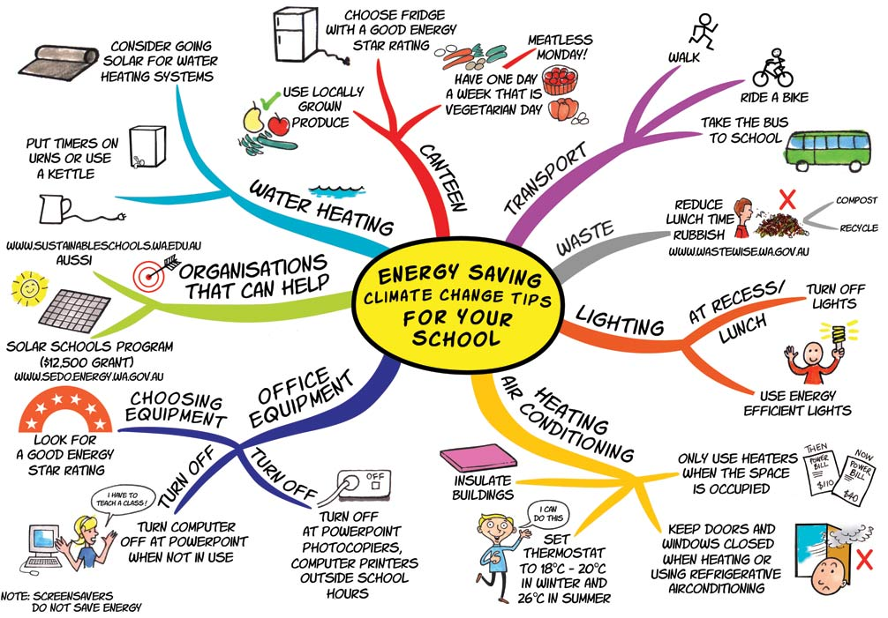
1. A laptop consumes less electricity than a desktop.
2. Switching off a computer shortens its lifetime.
3. Halogen lamps are more economical than fluorescent tubes.
4, Laser printers are less economical than inkjet ones.
5. Electrical heating is more efficient than gas heating.
6. Refrigerators with a built-in frozen food compartment are a good choice.
7. Most modern electrical appliances do not consume electricity in the standby mode.
8. About 70% of energy is lost before electricity reaches our home.
Text 6 – Non-renewable energy resources
Production of the electrical energy is based on rotating turbines attached to electrical generators. Turbines may be driven by the energy of steam, water, wind or other resources. The most common turbine driver is steam in fossil fuel power plants or nuclear power plants.
For example coal-fired units produce electricity by burning coal in a boiler to heat water and produce steam. The steam flows into a turbine, which spins a generator to produce electricity. The steam is cooled, condensed back into water and returned to the boiler to start the process over.
The problem with fossil fuels is that they will not last forever and when combusted, they generate sulphur dioxide, nitrogen oxides and carbon dioxide. These emissions cause acid rains and the greenhouse effect.
Much cleaner processes of producing energy take place in nuclear power plants. They are basically steam power plants fueled by splitting a radioactive element, like uranium. The splitting process is known as fission
Nuclear power plants nowadays produce about 17% of the world´s electric power, but there is still problem to be solved with spent fuel that is toxic for centuries. There is no safe, permanent storage facility for the spent radioactive elements yet.

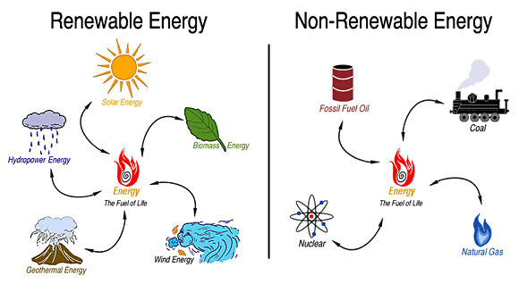
Text 7 – Renewable energy resources
The most used renewable source is hydropower. Most of it comes form the dammed water which drives a water turbine and generator. Less common is the use of tidal and wave energy.
Wind power has been used for centuries (remember windmills). We can use the wind by building a tall tower with a large propeller on the top. The wind turns the propeller round, which turns a generator to produce electricity.
As for the Sun´s energy, there are 3 main ways of use: solar cells (known as "photovoltaic"), which convert light directly into electricity, solar water heating, where the heat from the Sun is used to heat water in glass panels on your roof, and solar furnaces, which use a huge array of mirrors to concentrate the Sun´s energy into a small space and produce a very high temperature - the heat is then used to generate electricity.
Some other ways to produce enery using renewable resources include eg. burning biomass, using geothermal energy or solar chimneys.
QUIA activity 2 – Energy resources quiz
http://www.quia.com/quiz/2176276.html
Lesson 4 – Going green
Text 7 - Teen action
In this text there are 15 words printed in bold, but only 5 of them are correct. Can you find and change the 10 wrong words? Write the incorrect + correct words into your exercise-books.
In 2004, 120 youth people between the ages of fourteen to seventy from ten European countries met in Berlin at the First Youth Conference. There they discussed their planes for improving the environment in their own towns and villages. They focused on areas like recycling, saving energetic and reducing pollution. Then they wrote letters giving ideas for improving the environment locally, nationally and globally. Here are some of the things they thing we should do:
1. recycle more rabbits (eg. glass, paper, plastic, metal)
2. use our cars less - use public transports and bikes, walk
3. stop polluting rivers and steams
4. pick up rubbish in parks and in the streets
5. safe energy - turn off lights and TVs when not using them
6. do not use too many pesticides on farms
7. use recycling paper
8. use textile sleeping bags instead of plastic bags
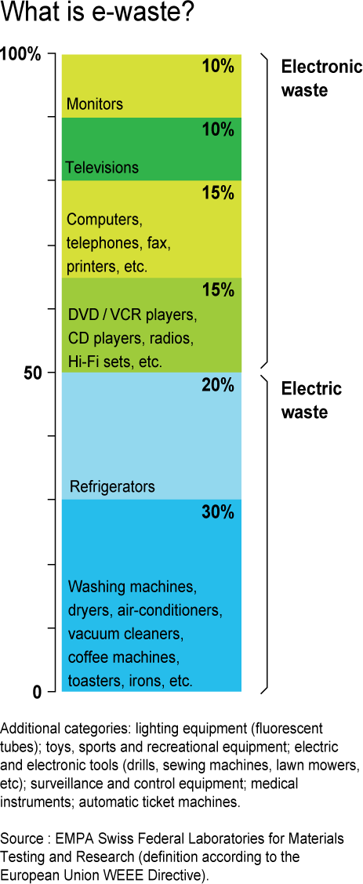
Text 8 – E-waste
Expansion of the global market for electrical and electronic products continues to accelerate, while the lifespan of the products is dropping. This results in the explosion of electronic scrap - every year, 20-50 million tonnes of e-waste are generated worldwide.
A mobile phone consists of 500 to 1000 components, many of them containing toxic heavy metals and hazardous chemicals. Polluting PVC plastic is also frequently used in electronic devices. That is why European Union have introduced legislation making producers responsible for their end-of-life products.
Where does e-waste end up?
At landfills, toxic chemicals in electronic products can leach into the land over time or are released to the atmosphere. Burning e-waste in incinerators releases heavy metals such as lead, cadmium or mercury into the air and ashes. Mercury can bio-accumulate in the food chain, especially in fish. Exporting of e-waste by developed countries often means violation of international law and its recycling in developing countries is usually done by hand in scarp yards, often by children .
In developed countries, electronics recycling takes place in purpose-built recycling plants under controlled conditions. In many EU states plastics from e-waste are not recycled to avoid dioxins and other greenhouse gases being released into the atmosphere.
Test 4 – Find the terms
1. The length of the time that something is likely to live, continue or function is _________________ .
2. Involving risk or danger is _______________ .
3. A poisonous silvery liquid metal used in thermometres is _________________________ .
4. Treating things that have already been used so that they can be used again is __________________.
5. The mixture of gases that surrounds the earth is ___________________ .
6. Match terms A and B. A: developed, recycyling, food, greenhouse, generate, introduce
B: countries, plants, law, chain, gases, e-waste
7. Make collocations. A: global, greenhouse, acid, ozone, acid, nuclear
B: waste, layer, rain, effect, warming
QUIA activity 3 – Environment terms Hangman
Try this activity at least twice - there are different words every time. Write all the terms you guess (or not guess) into your exercise books:
http://www.quia.com/hm/615120.html
Lesson 5 – Revision
Test 5 – Acid rain, global warming
1. Acid rain first became a problem in the Industrial revolution, but it is getting worse today. There is more ________________ form large cities, especially from power stations.
a, pollution b. destroys c. temperatures d. the Earth e. atmosphere

2. The pollution enters the _______________ and falls down as acid rain.
a. Earth b. temperatures c. destroys d. atmosphere e. pollution

3. Acid rain __________ forrests and can kill life in rivers and lakes.
a. destroys b. like c. temperature d. improves e. American

4. We can see the ______________ of acid rain in eastern Canada, Scandinavia and central Europe.
a. atmosphere b. resulting c. effects d. west e. pollution

5. The Greenhouse effect describes the situation when the air around the __________ gets warmer because of gases which trap heat.
a. oceans b. atmosphere c. Earth d. pollution e. North and South Poles

6. Warmer air is a problem because if _________________ rise by 1°C, the sea level will rise by over 25 cm and many cities will be in danger.
a. hot b. atmosphere c. height d. heating e. temperatures

Test 6 – What is it?
1. the unwanted gases, etc. that are produced when making nucelar power
2. a type of oxygen around the Earth that stops the sun form harming the Earth
3. water that falls from the sky and contains chemicals that damage plants etc.
4. he way in which the Earth is slowly getting warmer because gases are stopping heat form leaving it
5. the way in which the Earth´s weather is getting warmer because of pollution

Test 7 – Saving our environment
1. Our environment is in trouble. Modern ways of living and today´s industries are ________________ it.
a. recycle b. recycling c. pollute d. polluting e. pollution

2. Most people think there is nothing they can do. This is not true. Everyone can do something to help _______________ our environment.
a. save b. recycle c. to save d. recycling e. to recycle
3. You can help to cut ______________ by taking the bus to work instead of your car.
a. pesticides b. saving c. cars d. recycling e. pollution
4. You can buy organic fruit and vegetables that have not been treated with _____________ .
a. unorganic staff b. farmers c. pesticides d. pollution e. farming

5. You can ________________________ all your cans, bottles and paper.
a. pollute b. keep c. recycle d. throw away e. save

6. There should be a _________________ centre somewhere near your home, so take the used cans, bottles and paper there.
a. polluting b. save c. recycling d. polluted e. recycled
Follow-up task – Your turn
What do you do to protect the environment? Discuss this topic with your neighbour and then write at least 5 sentences into your exercise-book.
