Energy – text version of the Moodle module prepared by Jakub Vaniš, student from L3, for the students of L1

Energy source

For everything we do we need an energy. Most amount of the energy comes from sun as light and heat. In power plants we use fossil fuels, like oil and coal. It was created by storing of animals and plants remains. But there's a problem – they're not unlimited! That's why we started with using renewable energy.
In renewable energy we can count Sun, wind and water. They'll be there almost forever and they don't pollute an environment.
Another type of energy is geothermal energy. It takes heat from the depths of the Earth. We can imagine it like an inverted fridge. Inside the fridge is cold and it makes heat outside. Geothermal power plant works contrary.

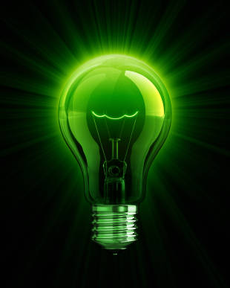
Dictionary

energy - energie
source – zdroj
renewable – obnovitelný
fossil fuels – fosilní paliva
powerplant/ powerstation – elektrárna
coal – uhlí
oil – ropa
wind – vítr
sun – slunce
water - voda
heat – teplo
coldness – chlad
geothermal – geotermální
pollution - znečištění
Easy test
1. Match the sources with types of energy

Oil
Coal Fossil
Wind Renewable
Water
Sun

2.Complete the sentence: Coal and oil are...
- fossil fuels
- unlimited
- renewable

3. Finish the sentence:
Coal is made by stored remains of plants and ........

4. True or false?
Coal belongs to renewable energy.

Quia - hangman
http://www.quia.com/hm/763859.html

Types of energy – watch and read

http://www.youtube.com/watch?v=nzQqWMlAgGg&feature=related
Water energy
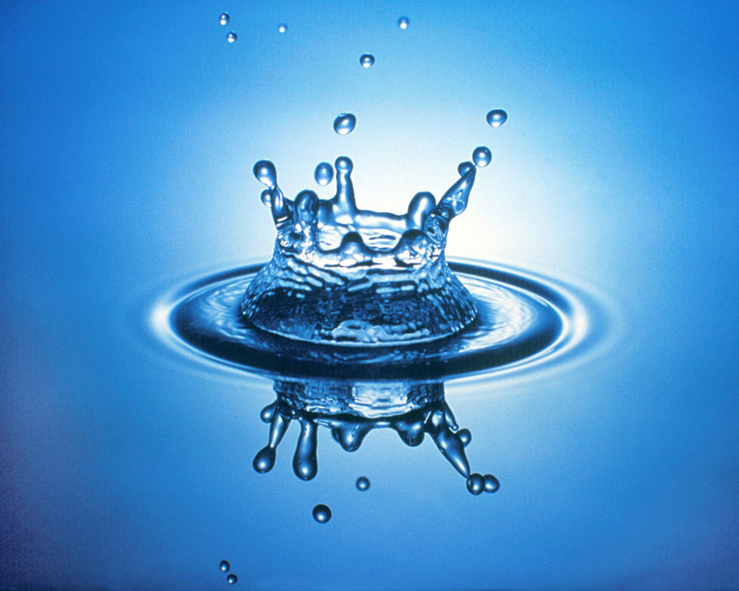

Water energy was used in middleage for powering mills. Now, we're using it for making electricity in hydroelectric powerstations. The princip is similar: streaming water is hitting the vanes and rotates turbine, which is generating electric current.
The amount of generated electricity depends on volume of water and difference between the water levels.

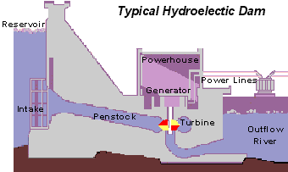
Water turbines

Pelton turbine:

- great levels difference
- small amount of water
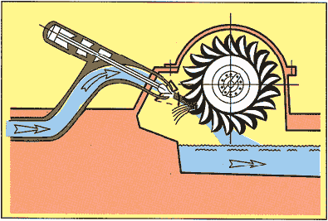

Francis turbine:

There are two wheels:
- one which is delivering water from dam and has changeable vanes
- second one, which rotates turbine
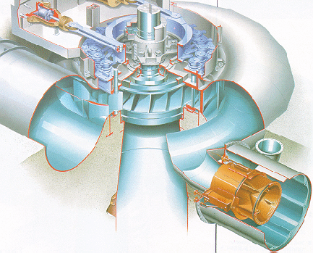

- Francis turbine is one of the most used turbines
- it's used for medium volume of water and medium levels difference

Kaplan turbine:

- similar to Francis turbine
- it has changeable vanes on the turbine round

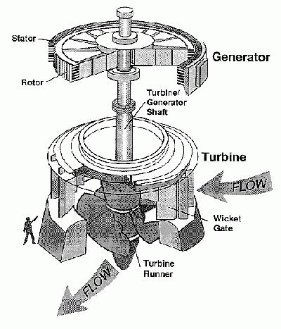
Banki turbine:
- used in small powerstations
- water flows through turbine "two times"
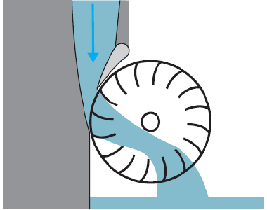
Water terms dictionary

water – voda
vanes – lopatky
turbine – turbína
flow/stream – vodní proud
water level – hladina
reservoir – nádrž
volume – objem

Watch the videos:

Three gorges: http://www.youtube.com/watch?v=tjTh7A4jnbc

Hydroelectric power – how it works: http://www.youtube.com/watch?v=cEL7yc8R42k&NR=1

Test – Water energy

1. True or false?
Banki turbine has changeable vanes

2. Finish the sentence:
Water has been used for powering _______

3. Complete the sentence:
Streaming water is hitting _______ and rotates the turbine.
- True or false?
The amount of generated electricity depends on volume of water and difference between the water levels.

- It's the part of dam, where the water is stored. What is it?

- What's the name of the biggest water dam in the world?

a. Three gorges (China)
b. Dlouhé stráně (Cze)
c. Hoover dam (USA)

- Match the correct words !
Two water circles Pelton turbine
Similar to Francis turbine Francis turbine
Their vanes looks like bowls Kaplan turbine
Wind energy
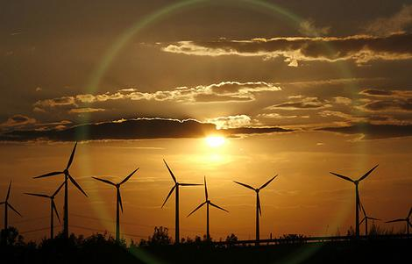
"Wind power is the conversion of wind energy into a useful form of energy, such as using wind turbines to make electricity, wind mills for mechanical power, wind pumps for pumping water or drainage, or sails to propel ships.
At the end of 2010, worldwide nameplate capacity of wind-powered generators was 196.6 gigawatts ."
(source : "http://en.wikipedia.org/wiki/Wind_power")

Main part of wind mill is gondola, where are the most important things like generator, gearbox, brakes and many others.
The princip is still the same. Wind hits blades and they rotate turbine inside of gondola, which generates electric current in generator.
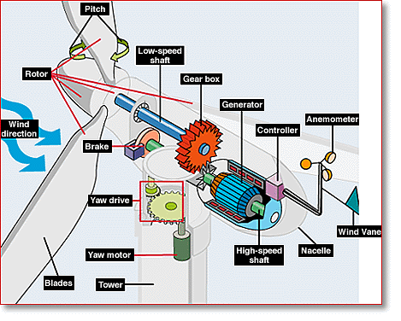

Solar energy
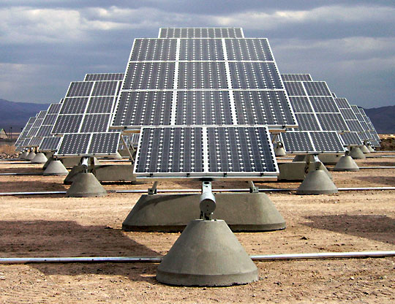
By the radiaton from Sun are light and heat delivered on the Earth. People, animals and plants use solar energy for milion years. Nowadays we use solar energy as another type of energy source.
Solar energy is collected at solar farms (foto-voltaic powerplants) with help of solar panels.

Wind and sun hangman

http://www.quia.com/hm/766572.html
Big finishing test
- Copmlete the sentence:
Solar energy can be used not only for making electricity. We can also heat _____ in solar collectors.

2. Copmlete the sentence
Most amount of energy comes from ____.

- The main part of wind powerplant, where are placed the most important things is called :
- wind mill
- turbine
- gondola
- gearbox

- True or false?
At the end of 2010, worldwide nameplate capacity of wind-powered generators was 12 megawatts

- True or false?
Coal belongs to renewable energy.

6. Coal and oil aren't :
a. fossil fuels
b. renewable
c. limited

7. Write an example of renewable energy:

- True or false?
Collecting solar energy in photovoltaic power plants (solar farms) is effective and doesn't pollute the environment, but building solar power plants is expensive

